**What opportunities exist for the Big Mountain Resort to increase the revenue by 1.5M through increasing the facilities and setting the ticket price considering the market segment.**

We look through the national data for the different skiing resorts and generalize for the Big Mountain Resort. We do the data wrangling, the exploratory data analysis and finally we set up building the model for predicting the price.

During the cleaning process we fix the missing values, some typos with the data and also explore the target feature, the ticket price. On data exploratory, we perform to see the skiing resorts features according to the state, build the new features as per the state and capita.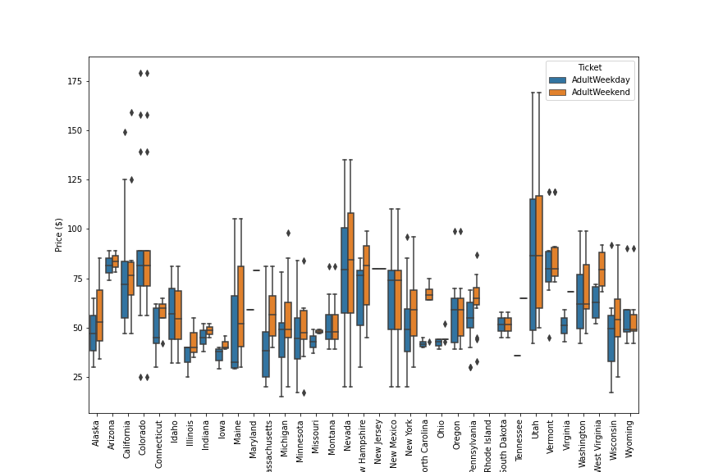

Here we see the ticket price is like mostly squeeze between $ 50-100 with some exceptions for states like California, Colorado and Utah. 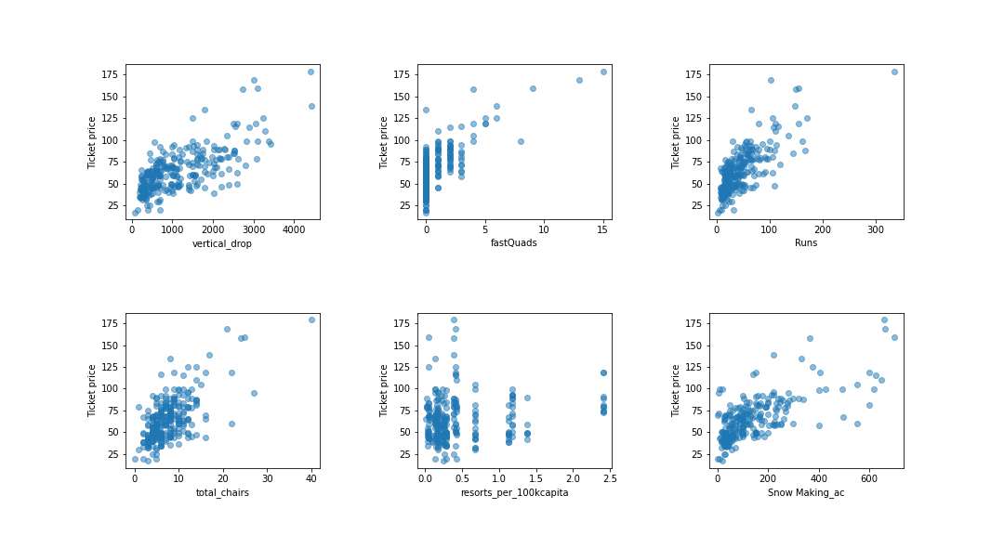

We sort some of the highly correlated features with the ticket price. And here I show the scatter plot for ticket price vs other features. We can see the runs, total chairs, vertical drop, fast quads, snow making, resorts per 100k capita have a strong positive correlation.

Finally, we came up with Random Forest Regressor as our final model and it predicts the ticket price to be $91 with a mean absolute error of 10.43 %. There is still some space to increase the price compared to the original price of $81. We further explore the change in the ticket price and revenue considering 350k visitors per season visiting for 5 days. We use the model and predict the change in revenue if we increase the runs, vertical drop, total chairs, 1, 150, 1 respectively to be $1512000.

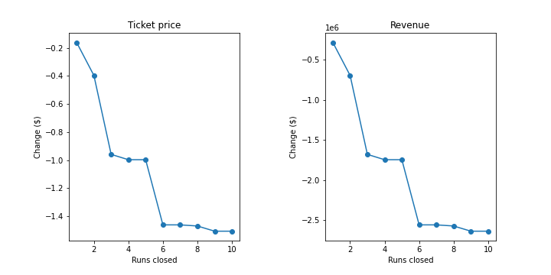

From the above graph, we see the revenue is decreasing with decrease in runs by 1 mile but further decreases by 2, 3 or 4 miles there is no change in revenue. This is one of suggestions for reducing the operating cost by closing the 2, 3 or 4 miles. This model can be used in predicting the ticket price in future if any new facilities are added or reduced.